Paper title: Capitalize the first letter of the title and the subtitle, if applicable

First author (First Name Last Name)¹; Second author (First Name Last Name)²
¹Afilliation, mail@mail.com, City, Country
²Afilliation, mail@mail.com, City, Country

Abstract
Your paper must contain an abstract with a maximum of 500 words. The abstract should contain the paper’s objective, the methodology used to solve the problem, and the results achieved. Submissions to the entrepreneurship competition should also emphasize the proposal’s innovative aspects, viability, and potential impact. Abstracts should be submitted in Word/.doc format using the Leading platform (link). Abstracts should be no longer than 2 pages and have a maximum of 500 words, with no references, images, or pictures.
Keywords: Include up to 5 keywords complementing the title and abstract, separated by semicolons
- Introduction
  - Congress publications
Accepted abstracts will be edited and published as a Book of Abstracts (max 2 pages) of the Open Access Series “Coleção Ativos de Engenharia” (Engineering Assets Collection).
Full-length papers (max. 18 pages) of selected top-quality research and industry manuscripts can be published in:
- English: Engineering Asset Management Review (EAMR), Springer Book Series (Scopus and EI Compendex).
- Portuguese/Spanish: Revista Ativos de Engenharia (ERA), Ponteditora Open Access Journals (Scopus indexation ongoing).
Selected contributions to the entrepreneurship competition can be published in a special issue:
- English/Portuguese/Spanish: Journal of Entrepreneurial Researchers (JER), Ponteditora Open Access Journals (Scopus indexation ongoing).
  - Work presentation
Each presentation shall last a maximum of 12 minutes, followed by up to 3 minutes for discussion with the audience. Oral presentation may be delivered in English, Portuguese, or Spanish. Presenters are free to choose their format (e.g., PowerPoint, PDF, etc.). It is recommended that the slides be presented in English, even if the oral presentation is in Portuguese or Spanish.
- Organization of the article
(Suggested chapters: Introduction, literature review, methodology, results and discussion, conclusion. The title and structure of the paper may vary according to the nature of the investigation. For example, entries for the entrepreneurship competition should include information about the team involved, the problem to be addressed, the proposed solution, and the project’s relevance in the context of CONGREGA).
NOTE:¹
Manuscripts should be no longer than 6 pages (including references and appendices). A non-edited version of all submitted manuscripts will be distributed to all registered participants.
Selected manuscripts can be extended up to 18 pages and undergo peer and editorial review for full-length papel publication in Engineering Asset Management Review or Revista Ativos de Engenharia (Journal of Engineering Assets).
Illustrations, such as figures, graphs, and tables, must be prepared according to APA standards, together with captions, credits, and the source file. If illustrations are imported from other programs, such as Excel and PowerPoint, also send the source file.
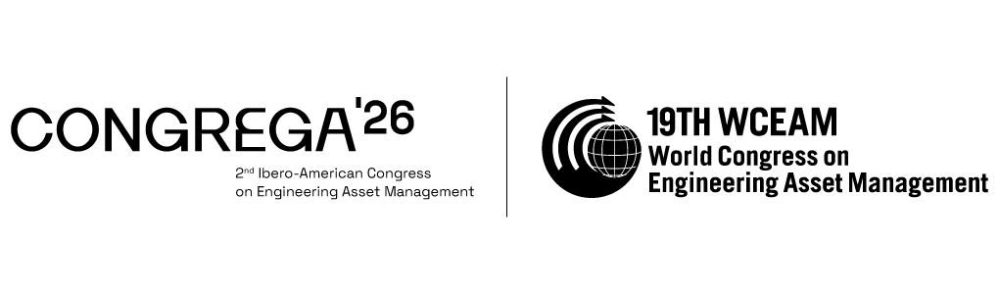
Figure 1 – Title (9 pt)
The text continues here
Arial Nova Condensed, size 11, line spacing 1,15, Arial Nova Condensed, size 11, line spacing 1,15.
Table 1 – Title (9 pt)
Title | Title | Title
Text 9 pt | Text 9 pt | Text 9 pt
Text 9 pt | Text 9 pt | Text 9 pt
¹ Tables may have a footer
The text continues here
Arial Nova Condensed, size 11, line spacing 1,15; Arial Nova Condensed, size 11, line spacing 1,15

________________
¹ Note
- Equation
This is example 1 of an equation:
$a+b=c$ Equation 1
Arial Nova Condensed, size 11, line spacing 1,15.
  - Chapter title level 2
Arial Nova Condensed, size 11, line spacing 1,15.
    - Chapter title level 3
Arial Nova Condensed, size 11, line spacing 1,15.
- Conclusions
Arial Nova Condensed, size 11, line spacing 1,15.
References
Arial Nova Condensed, size 11, line spacing 1,15; Arial Nova Condensed, size 11, line spacing 1,15
Citations must be made in the body of the text using the author-date system, including page numbers (when applicable), as per the American Psychological Association (APA) standards (https://libraryguides.vu.edu.au/apa-referencing/7StandardsPatents) Example: (Botura et al., 2018)
The complete references of the cited works must be presented in alphabetical order at the end of the text, according to the guidelines of the APA.
Botura, G. C., Wilson, T. M., & Hartzler, B. (2018). A method to join Nano technology carbon allotrope heaters. (European Patent No. EP3331317). European Patent Office. https://worldwide.espacenet.com/patent/search/family/060661756/publication/EP3331317A1?q=EP3331317

